The Ethnic Composition of the Crew of the St. Nikolai
Marcus Lepola, 8 Oct, 2018.
In my last article about the wedding comb, I raised the question of how a comb apparently belonging to a small Finno-Ugric group within the Russian Empire, ended up inside the wreck of Saint Nikolai? Since the discovery of the comb, another one of similar style and pattern has also emerged. The appearance of the second comb points to the Mordvins as well. The Mordvins were, however, not the only ethnic group onboard the St. Nikolai, as the following evidence will point out.
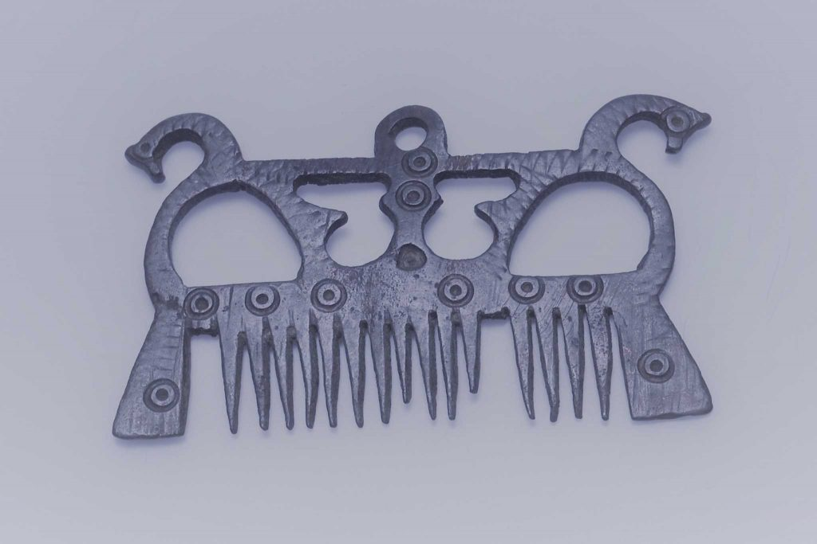 Mordvin wedding comb from the St. Nikolai from the Kymi Museum Collections. YLEE1778.

Turkish peoples in the Russian Fleet
Swedish reports from the aftermath of the battle tell us that Bashkirs were among the prisoners captured by the victorious Swedes. To their amazement they also discovered 60 Turks among the prisoners. The Turks had been in Russian captivity for two years and put to service as rowers in Russian fleet. We do not know if any Turkish prisoners of war were employed onboard the St. Nikolai as rowers. The Bashkir were a new acquaintance to the Swedes who during the two previous 18th century wars with Russia had encountered other nomadic peoples from the Russian steps such as, the Cossacks and Mongolian Kalmyks. The Bashkir language belongs to the Turkish language group and the Bashkir as well as the Turks adhered to Islam.
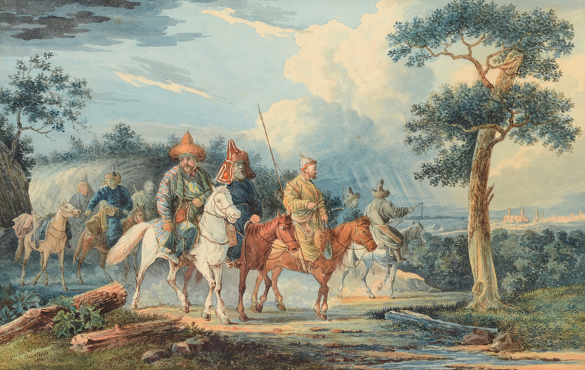 Bashkir riders in Europe in 1813. Башкирские казаки в Европе, 1813 год. Source Wikimedia commons.

Cossacks
Among the many ethnic groups in the Russian Army are the previously mentioned Cossacks, whom were drafted as cavalry. In the 18th century, the Russian Army also begun to produce arms that followed the traditional pattern of the Cossacks as their cavalry preferred the use of their own traditional weapons. A single curved sabre has been found from the wreck of the St. Nikolai. It is a Kindjal sword, traditional to Cossacks. This particular sabre is very similar to the much later models of the same sable, which the Russian Military issued in to the early 20th century. It is likely that a Cossack serving onboard the St. Nikolai wore this blade as a side arm. Several Cossack regiments from the region of Don are known to have served in Finland during the War of 1788–1790. Some of the cavalry were apparently onboard the Russian Fleet at the second battle of Svensksund.
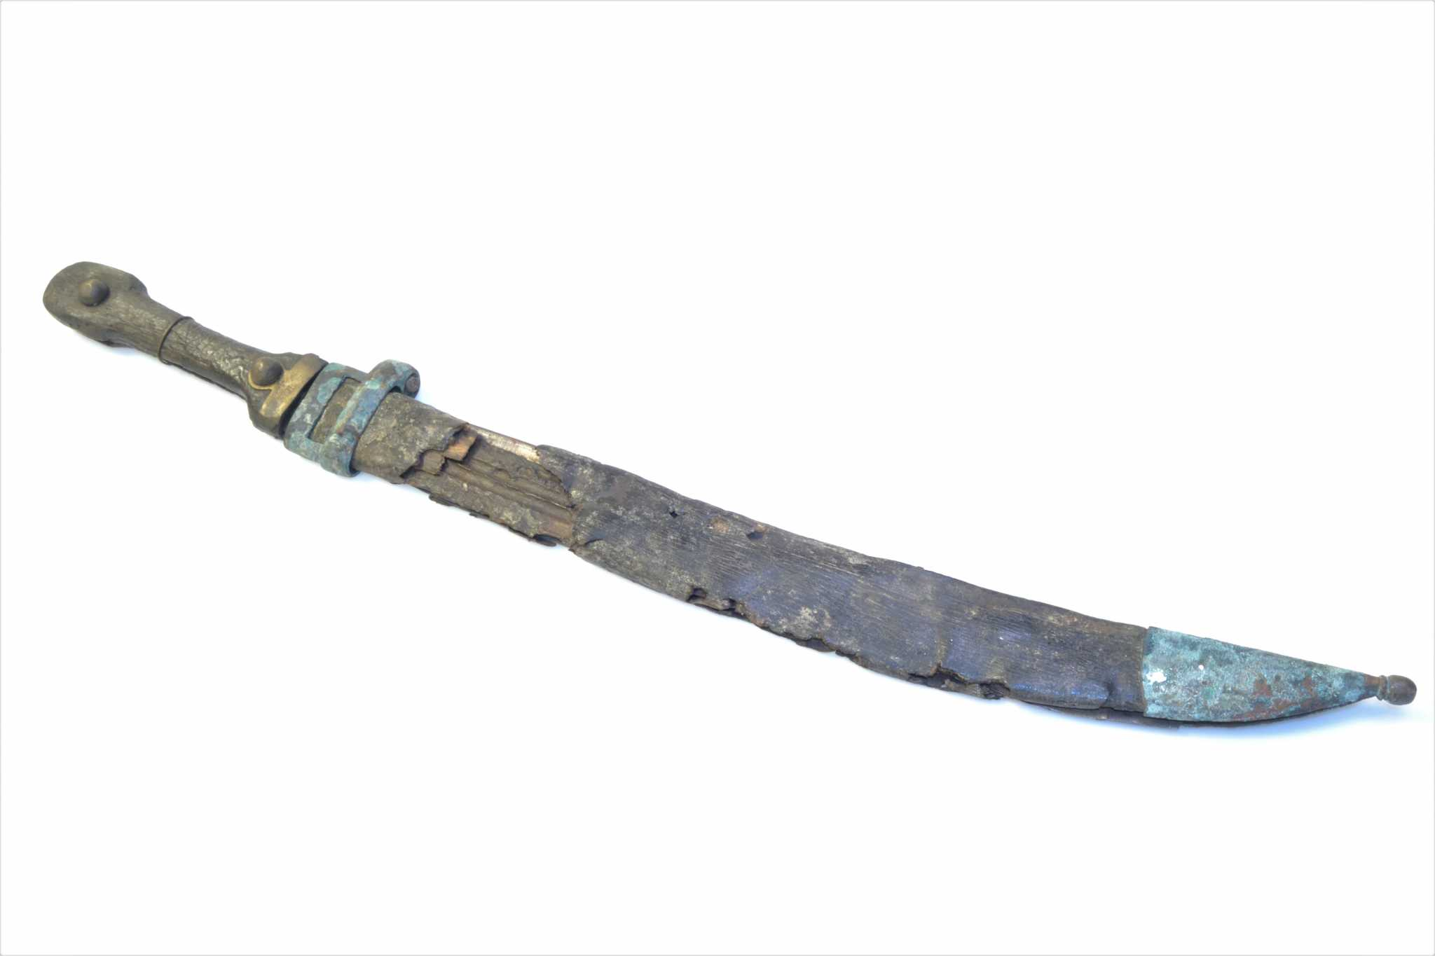 The Kindjal sword found in the wreck of the St. Nikolai. Kymi Museum Collections. YLEE1912.

British officers
It was also common in the Russian fleet for the commanding officers to be of another nationality and many English, Irish, Scottish as well as Italian and French officers served onboard the Russian fleet. The Baltic officers were of a Baltic German descent. Most foreign officers were British. Many of them had served in the American War of Independence (also known as The American Revolutionary War). French was the common language among the naval officers in the Russian fleet as both the British and the Russian officers knew how to speak it. Historians, such as Ordin, have viewed the use of a foreign language as a factor that contributed to the sad outcome for the Russian fleet. It is the reason why the commanding officers were unable to give direct orders to the Russian speaking crew and in the heat of battle problems of communication compounded to the Russian inability to mount a decisive attack against the Swedish lines at Svensksund in 1790.

As we can see the Russian Navy drafted men to service from a wide area and of varied ethnic origin. In addition, the commanding officers were from many different backgrounds, such as the captain of the St. Nikolai, the fearless young British officer Samuel E. Marshall, who like many others, suffered a sad fate at Svensksund.
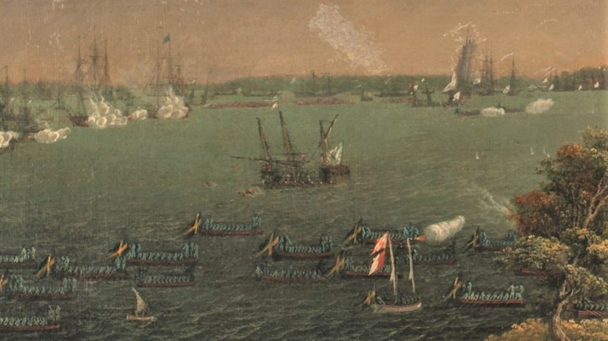 A sinking Russian vessel during the Battle of Svenksund 1790, possibly the St. Nikolai. By Schoultz. Swedish Naval Museum, O11269.

Sources
Svensksund 1790 – 1940. En minnesbok utarbetad av Försvarsstabens krigshistoriska avdelning. Sveriges Flotta, förening för sjövärn och sjöfart, Stockholm 1940. Harry Halén 1999.
Översikt över de ryska truppernas etniska sammansättning i Finland. Genos 70 (1999), p. 26-38, 66-67. Författarna och Genealogiska Samfundet i Finland. Matsson, Rainer 1991.
En rysk historikers skildring av slaget vid Svensksund 1790 (K F Ordin) p. 15-26. Forum Navale, Skrifter utgivna av Sjöhistoriska samfundet nr 47. Karlskrona.

Svensksund AD1790 – Kadotettu Ruotsinsalmi
